Ics 344 - sec 2 - Team 9
Phase 2
- Tools Used: Splunk
- Key Visualizations:
  - SSH brute force attack patterns
  - Failed login attempts
  - Source IP analysis
- Findings:
  - Identified attack patterns
  - Correlated events from multiple sources

- Install Splunk:
I have successfully downloaded splunk
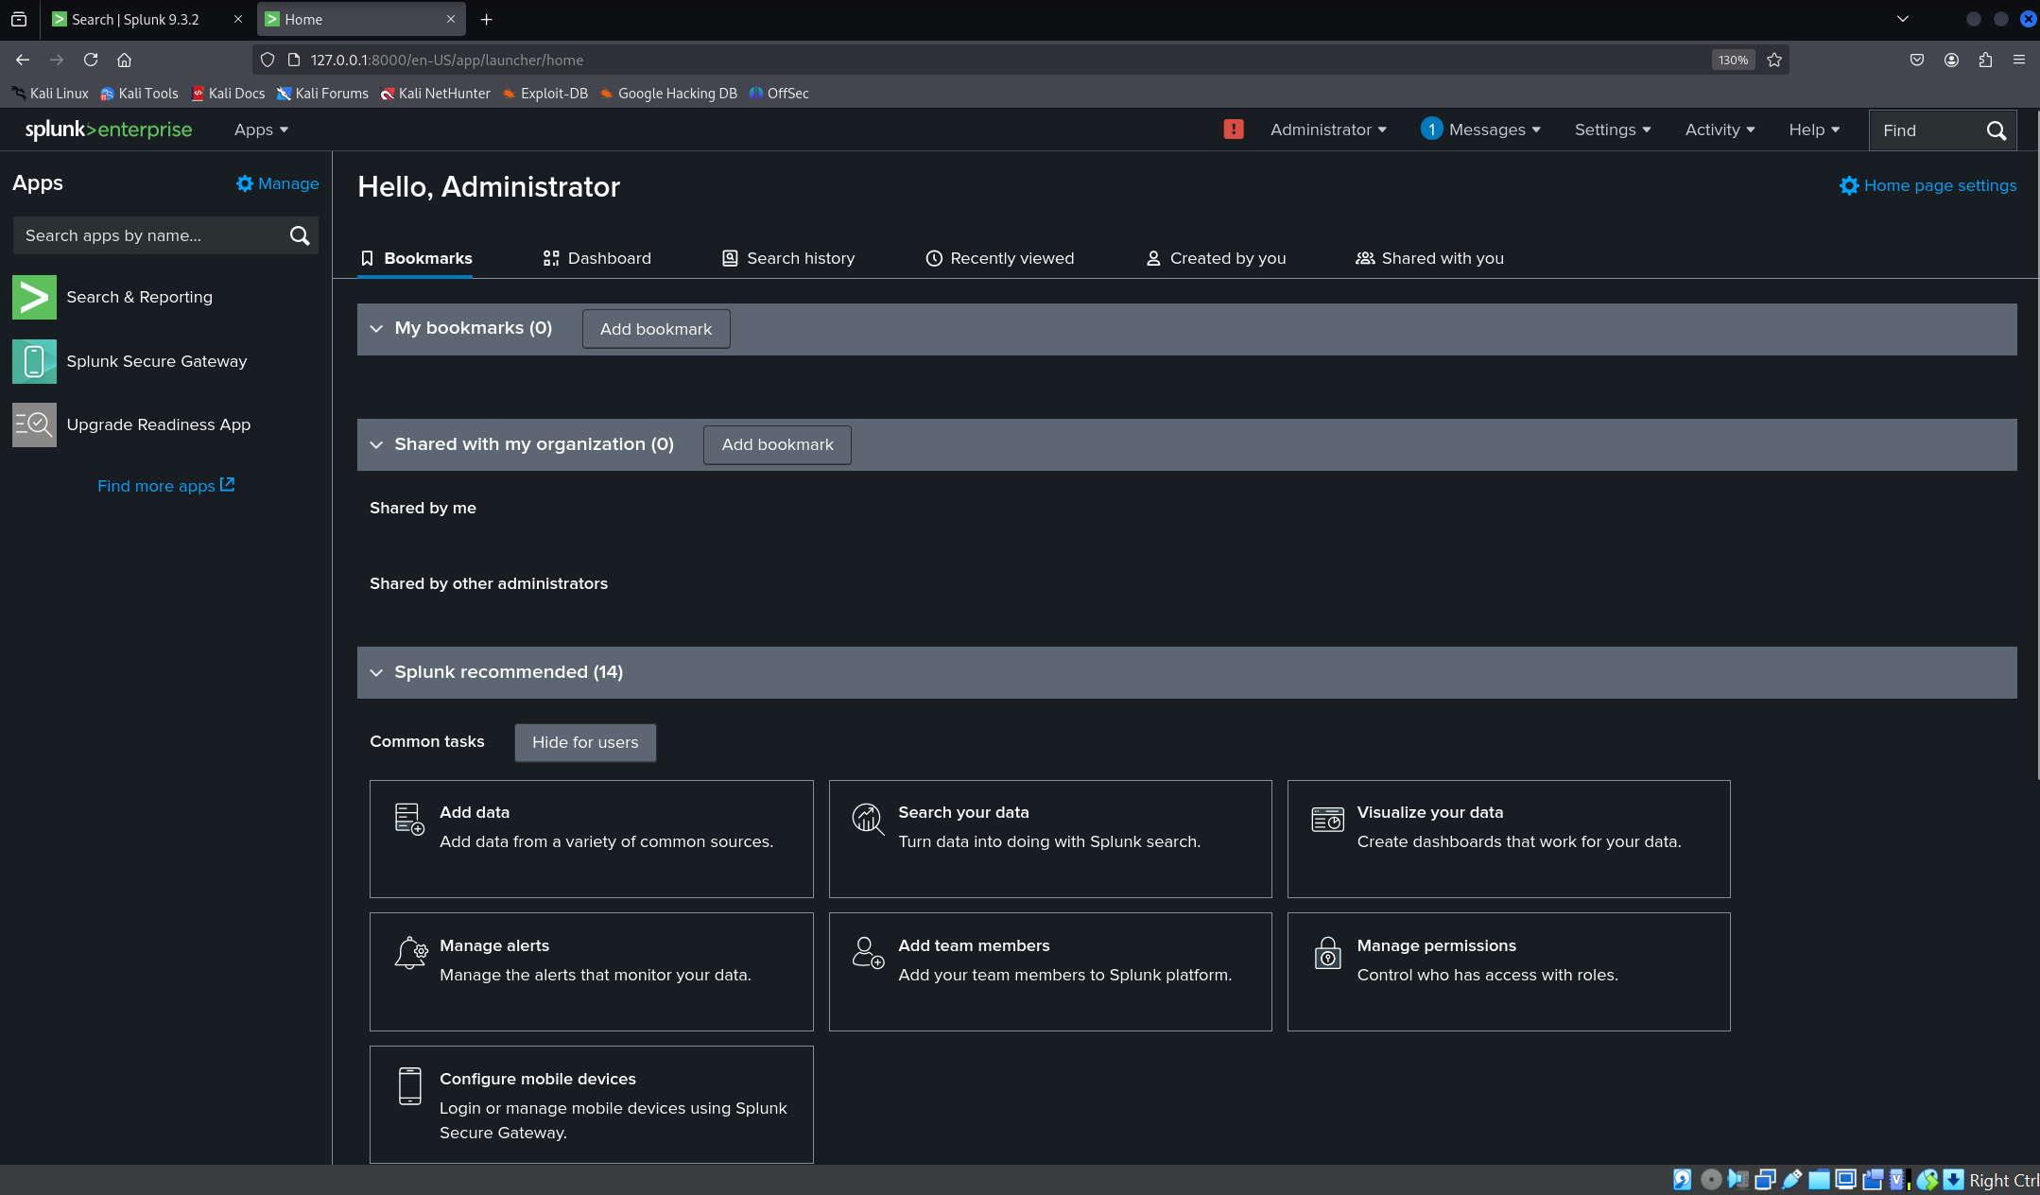
After putting the auth.log in Attacer VM splunk and searching on it the result came up as follows:
The count of both Failed and Accepted Password
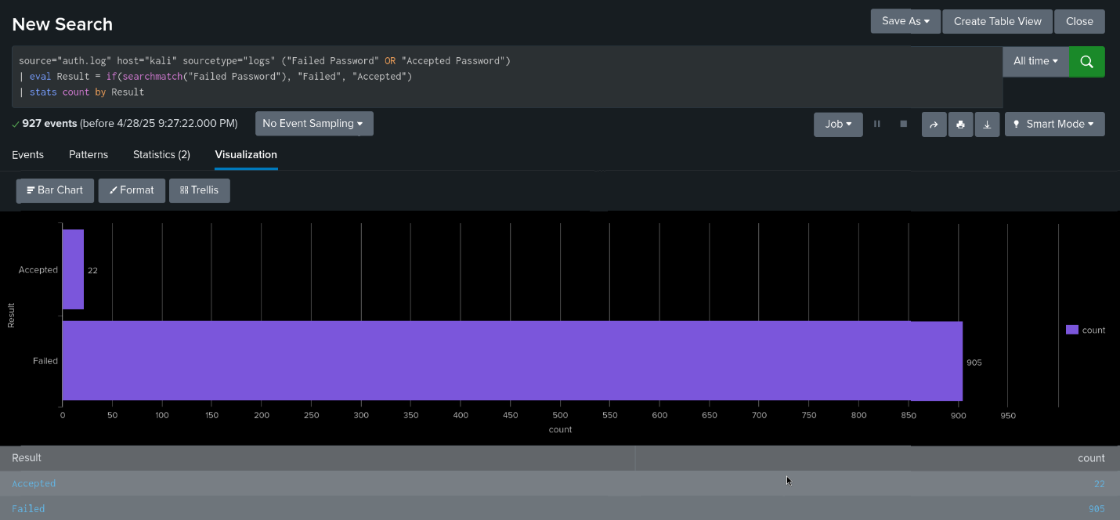

index=* source=”auth.log” “Failed password”
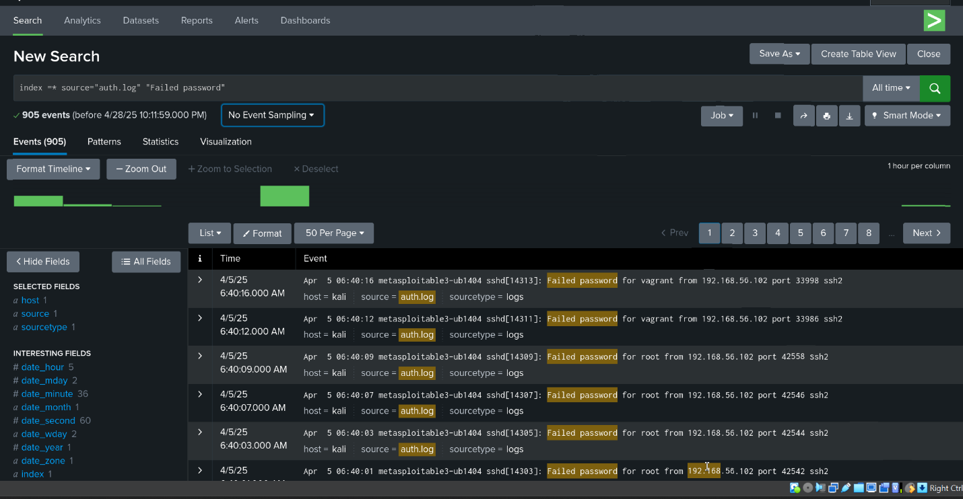
index =* source=”auth.log” “Accepted password “
